**Step motor**

11911214 杨鸿嘉

**1.Top Design Structure Diagram and Block Diagram**

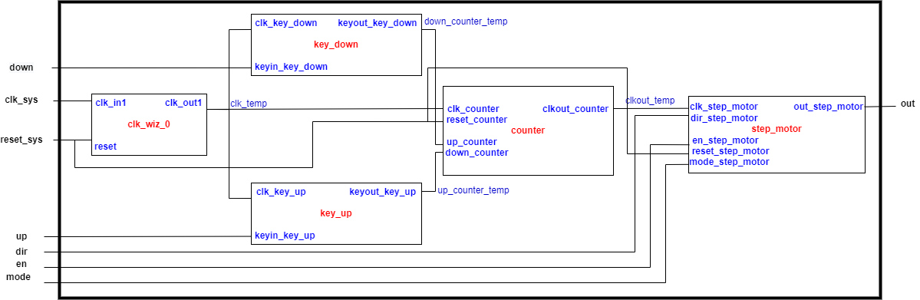

Block Diagram for Counter:

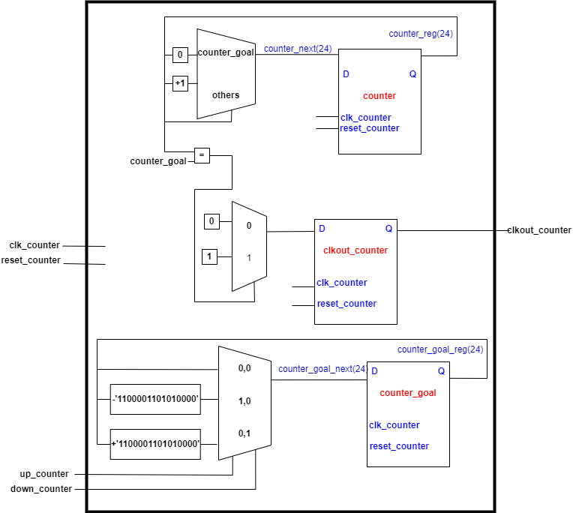

Block Diagram for Step_motor

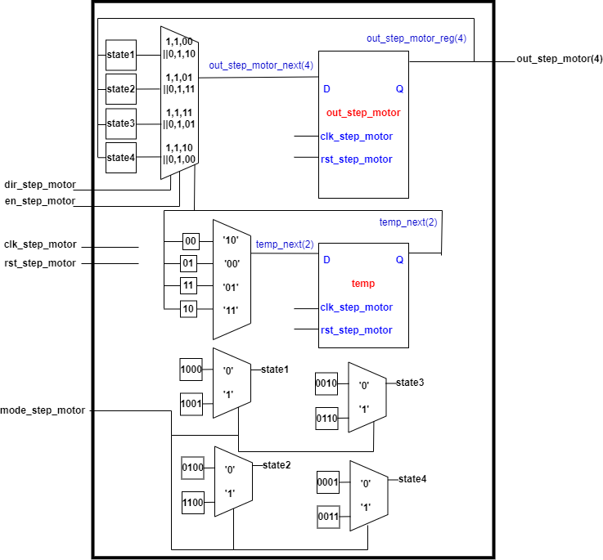

library IEEE;

use IEEE.STD_LOGIC_1164.ALL;

entity key_down is

Port (clk_key_down,keyin_key_down:in std_logic;

keyout_key_down:out std_logic );

end key_down;

architecture Behavioral of key_down is

signal count:integer;

begin

process(clk_key_down) is

begin

if(clk_key_down'event and clk_key_down='1') then

if(keyin_key_down='1') then

count<=count+1;

if(count=10000) then

keyout_key_down<='1';

else

keyout_key_down<='0';

end if;

else

count<=0;

end if;

end if;

end process;

end Behavioral;

1. **VHDL code for step_motor and Testbench code**

**library IEEE;**

**use ieee.std_logic_1164.all;**

**use ieee.std_logic_arith.all;**

**use ieee.std_logic_unsigned.all;**

**entity counter is**

**Port(clk_counter,reset_counter: in std_logic;**

**up_counter,down_counter:in std_logic;**

**clkout_counter: out std_logic);**

**end counter;**

**architecture Behavioral of counter is**

**signal counter: std_logic_vector(23 downto 0);**

**signal counter_goal: std_logic_vector(23 downto 0);**

**begin**

**process (clk_counter,reset_counter) is**

**begin**

**if reset_counter = '1' then**

**counter <= "000000000000000000000000";**

**--counter_goal<="000011110100001001000000";**

**counter_goal<="000000000000001111101000";**

**elsif clk_counter'event and clk_counter='1' then**

**if up_counter='1' then**

**counter_goal<=counter_goal-"1100001101010000";**

**elsif down_counter='1' then**

**counter_goal<=counter_goal+"1100001101010000";**

**else**

**end if;**

**if counter=counter_goal then**

**counter<="000000000000000000000000";**

**clkout_counter<='1';**

**else**

**counter<=counter+'1';**

**clkout_counter<='0';**

**end if;**

**end if;**

**end process;**

**end Behavioral;**

library IEEE;

use IEEE.STD_LOGIC_1164.ALL;

entity key_up is

Port (clk_key_up,keyin_key_up:in std_logic;

keyout_key_up:out std_logic );

end key_up;

architecture Behavioral of key_up is

signal count:integer;

begin

process(clk_key_up) is

begin

if(clk_key_up'event and clk_key_up='1') then

if(keyin_key_up='1') then

count<=count+1;

if(count=10000) then--对应现实20ms

keyout_key_up<='1';

else

keyout_key_up<='0';

end if;

else

count<=0;

end if;

end if;

end process;

end Behavioral;

Implementation for Elimination Buffeting of Keystroke:

Key_up and key_down is for Elimination Buffeting of Keystroke. The logic for this process is for each clk input, if the input of the button is in high level, use a counter to count the number of clk period with high level input. If this counter has value larger than 10000, this means that the button has been pushed and with only one time push, set the output signal high level. We through the elimination buffeting of keystroke problem through this method.

library IEEE;

use IEEE.STD_LOGIC_1164.ALL;

entity step_motor_top is

Port (clk_sys,rst_sys,en_sys,dir_sys,down_sys,up_sys,mode_sys:in std_logic;--'0' wave '1' fullstep

out_sys:out std_logic_vector(3 downto 0));

end step_motor_top;

architecture structure of step_motor_top is

component clk_wiz_0

port(clk_out1: out std_logic;reset: in std_logic;clk_in1: in std_logic);

end component;

component counter

Port(clk_counter,reset_counter: in std_logic;

up_counter,down_counter:in std_logic;

clkout_counter: out std_logic);

end component;

component step_motor is

Port(clk_step_motor,dir_step_motor,en_step_motor,rst_step_motor:in std_logic;

mode_step_motor: in std_logic;

out_step_motor: out std_logic_vector(3 downto 0));--ABCD

end component;

component key_down is

Port (clk_key_down,keyin_key_down:in std_logic;

keyout_key_down:out std_logic );

end component;

component key_up is

Port (clk_key_up,keyin_key_up:in std_logic;

keyout_key_up:out std_logic );

end component;

signal clk_temp,clkout_temp,up_counter_temp,down_counter_temp:std_logic;

begin

clkwiz : clk_wiz_0 port map (clk_in1 => clk_sys,reset => rst_sys,clk_out1=> clk_temp);

stepmotor:step_motor port map (clk_step_motor=>clkout_temp,dir_step_motor=>dir_sys,en_step_motor=>en_sys,rst_step_motor=>rst_sys,out_step_motor=>out_sys, mode_step_motor=>mode_sys);

counter_step: counter port map (clk_counter=>clk_temp,reset_counter=>rst_sys,clkout_counter=>clkout_temp,up_counter=>up_counter_temp,down_counter=>down_counter_temp);

keyup:key_up port map (clk_key_up=>clk_temp,keyin_key_up=>up_sys,keyout_key_up=>up_counter_temp);

keydown:key_down port map (clk_key_down=>clk_temp,keyin_key_down=>down_sys,keyout_key_down=>down_counter_temp);

end structure;

library IEEE;

use ieee.std_logic_1164.all;

use ieee.std_logic_arith.all;

use ieee.std_logic_unsigned.all;

entity step_motor is

Port(clk_step_motor,dir_step_motor,en_step_motor,rst_step_motor:in std_logic;

mode_step_motor: in std_logic;

out_step_motor: out std_logic_vector(3 downto 0));--ABCD

end step_motor;

architecture Behavioral of step_motor is

signal temp:std_logic_vector(1 downto 0);

signal state1,state2,state3,state4:std_logic_vector(3 downto 0);

begin

process(clk_step_motor,dir_step_motor,en_step_motor,rst_step_motor) is

begin

if rst_step_motor= '1' then

out_step_motor<="0000";

temp<="00";

elsif clk_step_motor'event and clk_step_motor='1' then

if en_step_motor='1' then

if dir_step_motor='1' then

if(temp="00") then

out_step_motor<=state1;

temp<="01";

elsif temp="01" then

out_step_motor<=state2;

temp<="11";

elsif temp="11" then

out_step_motor<=state3;

temp<="10";

else

out_step_motor<=state4;

temp<="00";

end if;

else

if(temp="00") then

out_step_motor<=state4;

temp<="01";

elsif temp="01" then

out_step_motor<=state3;

temp<="11";

elsif temp="11" then

out_step_motor<=state2;

temp<="10";

else

out_step_motor<=state1;

temp<="00";

end if;

end if;

else

out_step_motor<="0000";

temp<="00";

end if;

end if;

end process;

state1<="1000" when mode_step_motor='0' else "1001";

state2<="0100" when mode_step_motor='0' else "1100";

state3<="0010" when mode_step_motor='0' else "0110";

state4<="0001" when mode_step_motor='0' else "0011";

end Behavioral;

Testbench code:

library IEEE;

use IEEE.STD_LOGIC_1164.ALL;

entity key_down_tb is

end key_down_tb;

architecture behavior of key_down_tb is

component key_down

Port (clk_key_down,keyin_key_down:in std_logic;

keyout_key_down:out std_logic );

end component;

signal clk_key_down_tb,keyin_key_down_tb,keyout_key_down_tb: std_logic;

begin

uut: key_down PORT MAP (clk_key_down=>clk_key_down_tb,keyin_key_down=>keyin_key_down_tb,keyout_key_down=>keyout_key_down_tb);

keyin_key_down_tb<='0', '1' after 1ms,'0' after 1.005 ms,'1' after 1.010ms, '0' after 1.015ms, '1' after 1.020ms,'0' after 1.025ms,'1' after 1.03ms,'0' after 1.035ms, '1' after 1.040ms, '0'after 1.045ms, '1' after 1.05ms;

clock_gen: process

constant period : time := 100 ns;

begin

clk_key_down_tb <= '0';

wait for period/2;

clk_key_down_tb <= '1';

wait for period/2;

end process;

end behavior;

library IEEE;

use IEEE.STD_LOGIC_1164.ALL;

entity step_motor_top_tb is

end step_motor_top_tb;

architecture behavior of step_motor_top_tb is

component step_motor_top

Port (clk_sys,rst_sys,en_sys,dir_sys,down_sys,up_sys,mode_sys:in std_logic;--'0' wave '1' fullstep

out_sys:out std_logic_vector(3 downto 0));

end component;

signal clk_sys_tb,rst_sys_tb,en_sys_tb,dir_sys_tb,down_sys_tb,up_sys_tb,mode_sys_tb: std_logic;

signal out_sys_tb:std_logic_vector(3 downto 0);

begin

uut: step_motor_top PORT MAP (clk_sys=>clk_sys_tb,rst_sys=>rst_sys_tb,en_sys=>en_sys_tb,dir_sys=>dir_sys_tb,out_sys=>out_sys_tb,

down_sys=>down_sys_tb,up_sys=>up_sys_tb,mode_sys=>mode_sys_tb );

rst_sys_tb<='0', '1' after 10 ns,'0' after 50 ns;

dir_sys_tb<='1';

en_sys_tb<='1';

down_sys_tb<='0';

up_sys_tb<='0';

mode_sys_tb<='0';

clock_gen: process

constant period : time := 10 ns;

begin

clk_sys_tb <= '0';

wait for period/2;

clk_sys_tb <= '1';

wait for period/2;

end process;

end behavior;

1. **Simulation Result**

**Behavior simulation**

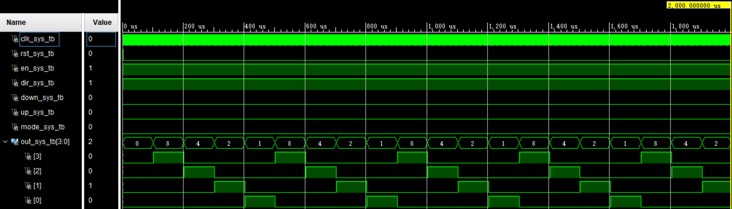

After reset, the program work well according to our setting, we can see the output waveform of the step motor.

**Post-synthesis functional simulation:**

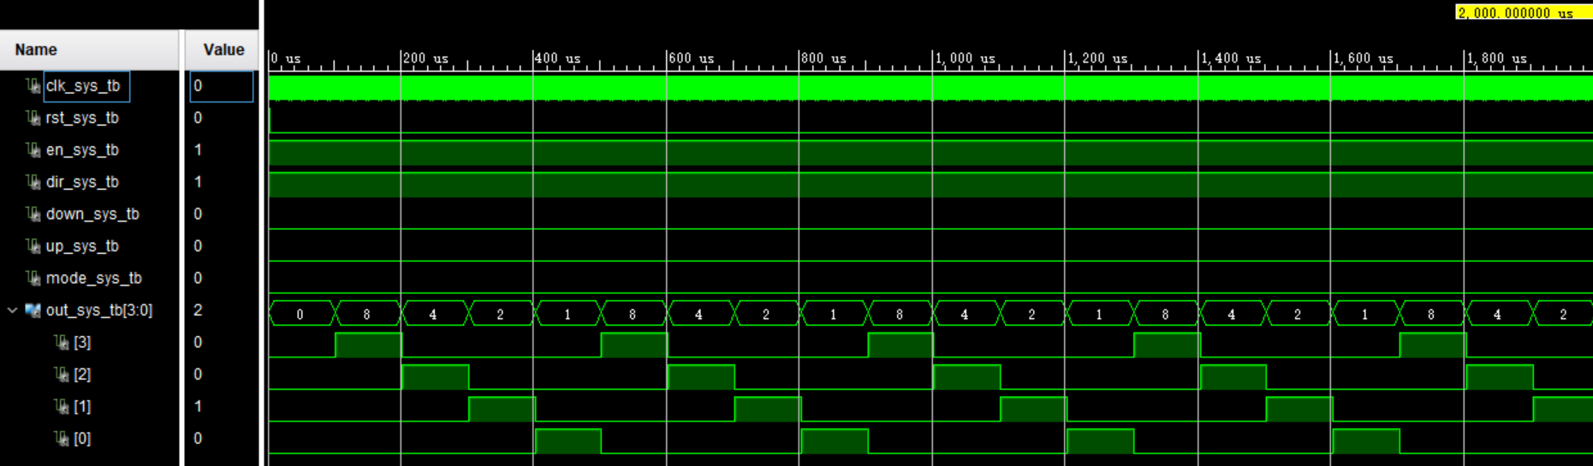

**Post-synthesis timing simulation:**

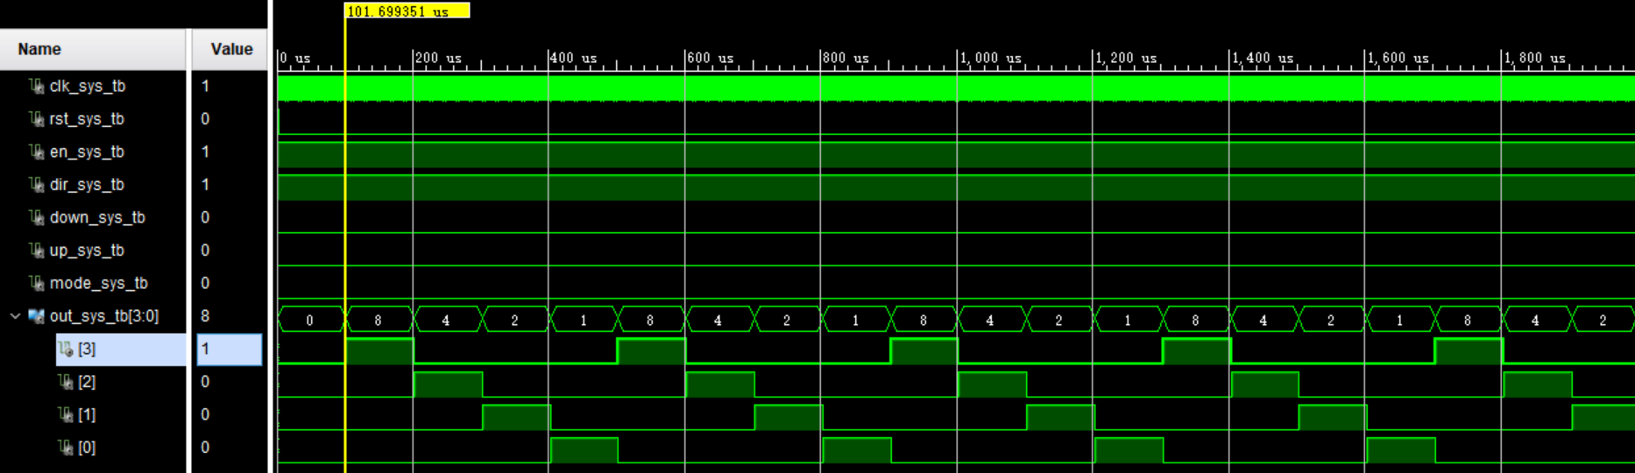

For the post-synthesis timing simulation result, we can find the delay for the output is nearly 1.699us.

**Post-Implementation functional simulation:**

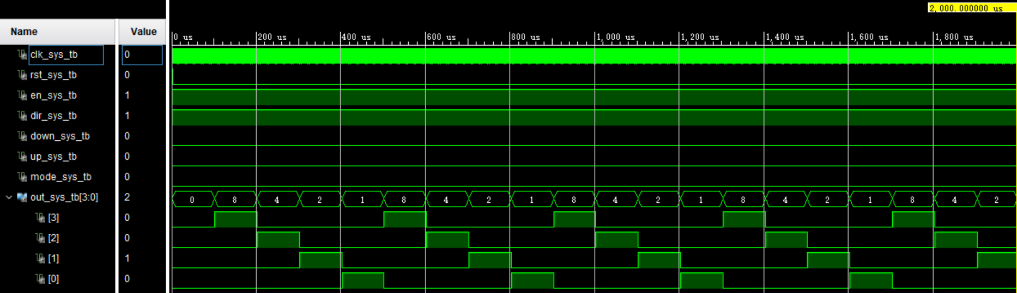

**Post-Implementation timing simulation:**

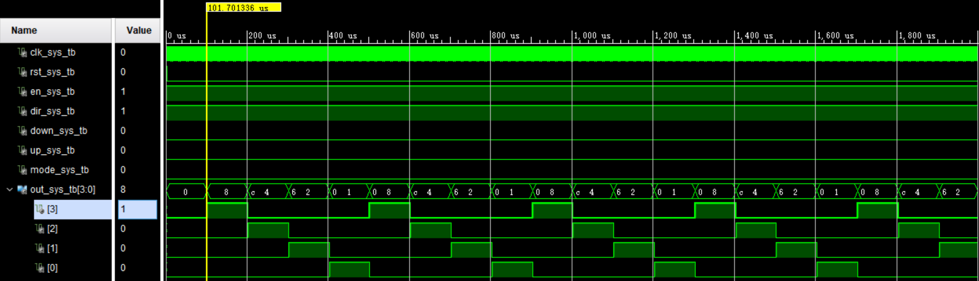

From the post-implementation timing simulation, the delay for the output is 1.70us, which is larger than post-synthesis simulation. We can see the competitive adventure phenomenon and the output waveform for step motor has delay for near step, that is:

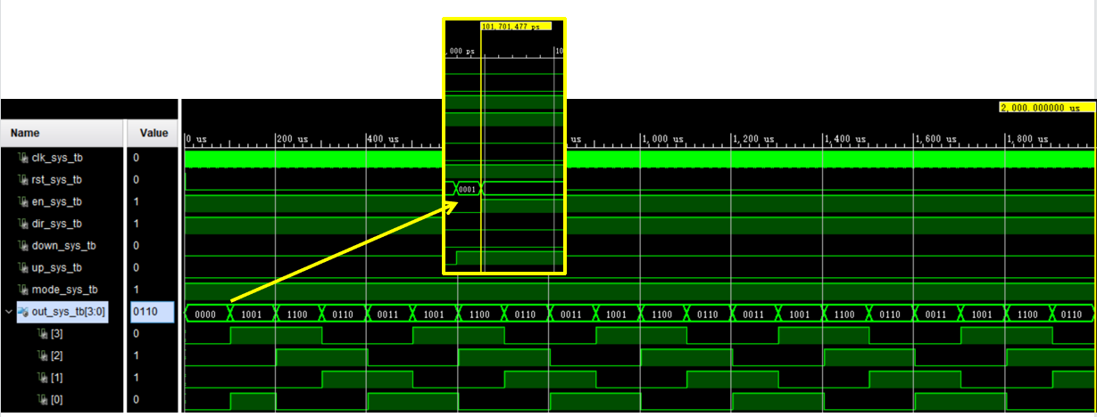

We can see that the four step are not closely alternating, there may be slight overlap and neutral period. But this will not influence our actual performance.

**Different direction post-implementation timing simulation:**

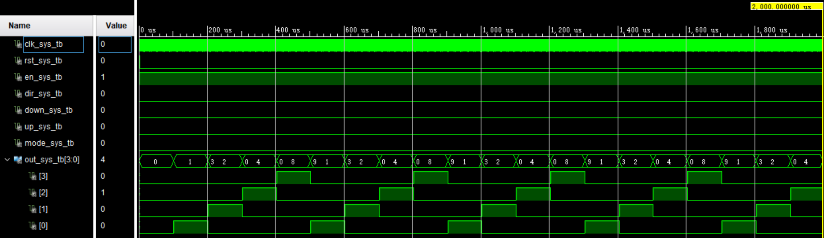

**Full step drive post-implementation timing simulation:**

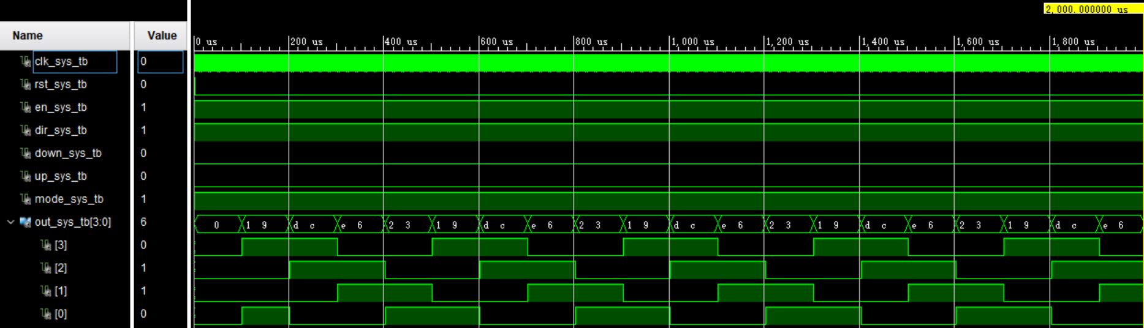

**Testing for the Elimination Buffeting of Keystroke:**

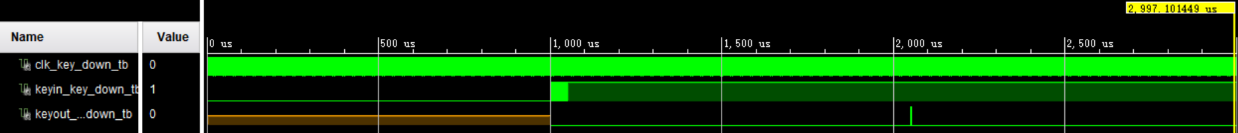

We can find that the Elimination Buffeting of Keystroke work as our expect.

**4 Simulation Resource:**

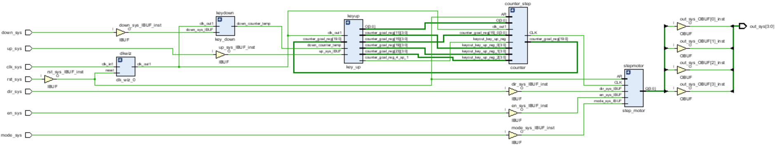

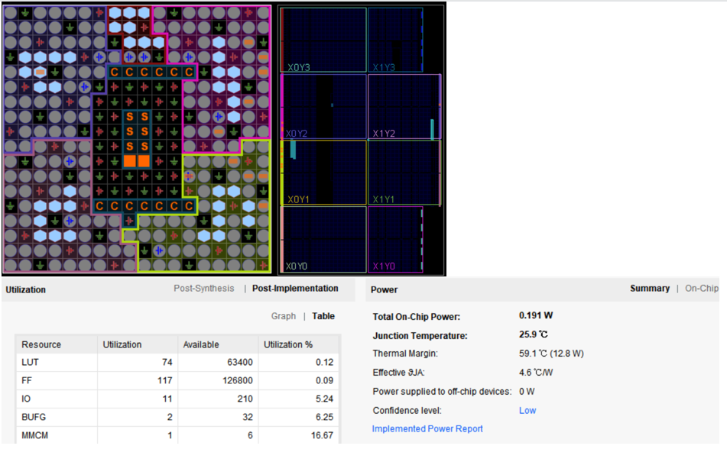

**5 Actual Testing**

